
THE HONG KONG

POLYTECHNIC UNIVERSITY

Department of Computing

Tutorial - 1

Biometrics Authentication COMP435p

- Answer the following questions:

- Understand the reasons why biometrics security in e-world. (P1: 4-11)
- What is biometrics? (P1: 13-14; P2: 3-6)
- Understand two types of biometrics and give some examples respectively. (P2:7-8)
- The definition of enrollment, template and matching in a biometrics system. (P2:11-13)
- What are the requirements of a biometric feature used for authentication purposes? (P2:20-28)

- Which difference between identification and verification? (P2: 35-36)

- What makes up a biometric authentication system? (P2:31-34). Please give an example to explain them.

- Compare enrollment mode and authentication/verification mode. (P2: 37-38)

- What are FRR, FAR, EER, Crossover, FTE, ATV and ROC? (P2: 17-19) Now there are two FAR-FRR diagrams and one ROC curve. Give the EER respectively. When FRR=0.1, how about FAR and Crossover, respectively? If the corresponding FTE are all equal to 0.05, then how about ATV? (For (a), EER=0.06, FAR=0.03, Crossover=1/17, ATV=0.855; For (b), EER=0.09, FAR=0.07, Crossover=1/11, ATV=0.855; For (c), EER=0.08, FAR=0.05, Crossover=1/13, ATV=0.855)
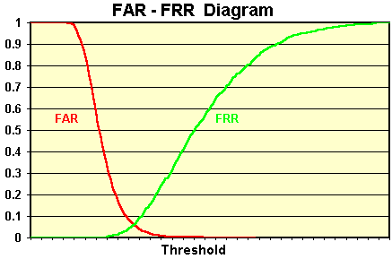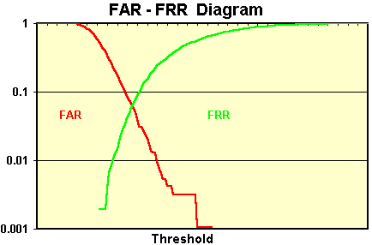
(a) (b)

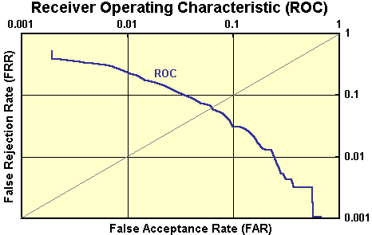
(c)

- 100 individuals try to use a biometric system. There are 38 genuine individuals are accepted, 8 genuine individuals rejected, 44 imposter rejected and 10 imposter accepted. Please evaluate the biometric system by giving the FAR and FRR. If FTE=0.05, then how about ATV? (FAR=0.19, FRR=0.17, ATV=0.79)

